DBMS LAB ASSIGNMENT-1

**NAME: KOLA LOKESH**

**ROLLNO:19BCS056**

ER-DIAGRAM:

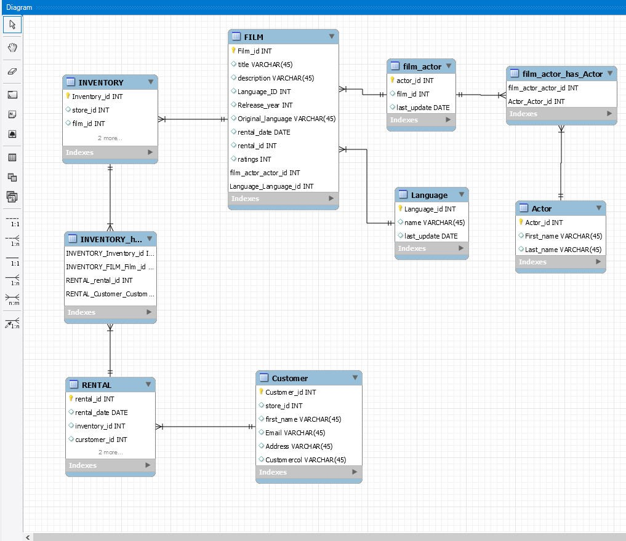

Weak entity:

An entity type should have a key attribute which uniquely identifies each entity in the entity set, but there exists some entity type for which key attribute can’t be defined. These are called Weak Entity type.

As the weak entities do not have any primary key, they cannot be identified on their own, so they depend on some other entity (known as owner entity). The weak entities have total participation constraint (existence dependency) in its identifying relationship with owner identity. Weak entity types have partial keys. Partial Keys are set of attributes with the help of which the tuples of the weak entities can be distinguished and identified.

**• No weak entities cause every table has a primary key**